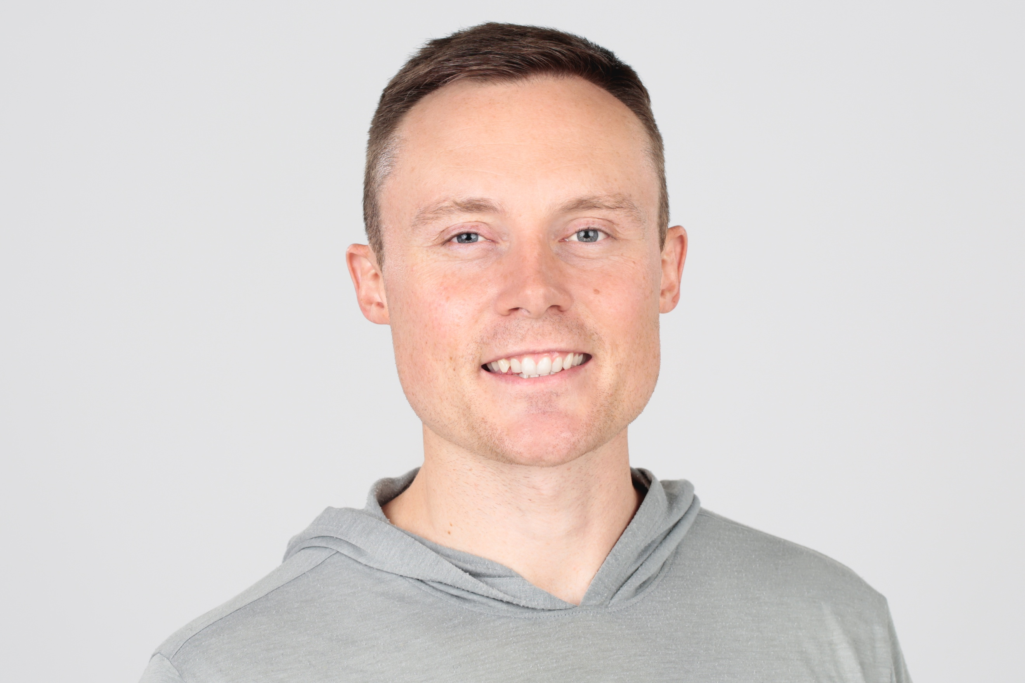

ABOUT THE AUTHOR
Dr. Benjamin Hardy is an organizational psychologist and bestselling author of Willpower Doesn’t Work. His blogs have been read by over 100 million people and are featured on Forbes, Fortune, CNBC, Cheddar, Big Think, and many others. He is a regular contributor to Inc. and Psychology Today and from 2015-2018, he was the #1 writer, in the world, on Medium.com. He and his wife Lauren adopted three children through the foster system in February 2018 and, one month later, Lauren became pregnant with twins, who were born in December of 2018. They live in Orlando.

ABOUT THE BOOK
In Personality Isn’t Permanent, Dr. Benjamin Hardy draws on psychological research to demolish the popular misconception that personality—a person’s consistent attitudes and behaviors—is innate and unchanging. Hardy liberates us from the limiting belief that our “true selves” are to be discovered, and shows how we can intentionally create our best selves and achieve big goals instead. He offers practical, science-based advice to for self-reinvention, including:
- Why you should never be the “former” anything—defining yourself by your past successes can be just as damaging to your potential to grow as being haunted by past failures
- How to design a desired vision of your future self and make decisions based on what the future you would want
- Why personality tests such as Myers-Briggs and Enneagram are not only psychologically destructive but are no more scientific than horoscopes
- How to tap into what psychologists call “pull motivation” by narrowing your focus on a single, definable, and compelling outcome.

ADVANCED PRIASE

“Personality Isn't Permanent is possibly the best self-help book I've ever read, and a book that will redefine the genre. After this book, it's no longer good enough to talk about untested theory—Hardy backs everything up with both amazing stories and cutting edge, tested science, while still making it actionable to anyone. Best part: this is the book that destroys all the useless personality test peddlers that infect the world."
—Tucker Max

"In Personality Isn’t Permanent, Dr. Hardy crushes an outdated paradigm and gives you the process to create a bigger, bolder future."
—JJ Virgin

"Ben Hardy is proof of what he writes about. He keeps getting better and better--and so can you."
—Ryan Holiday

“Personality Isn’t Permanent provides a robust science-backed roadmap for helping you rewrite your self-limiting stories—and to keep writing and editing them for success throughout your lifelong journey."
—Dr. Steven G. Eisenberg

“As the saying goes, the future isn’t what it used to be. Benjamin Hardy illustrates this truth perfectly in Personality Isn’t Permanent, providing both method and motivation to frame your future as the best version of you.”
—Harvey Mackay

POTENTIAL INTERVIEW QUESTIONS

“Anyone who isn't embarrassed of who they were last year probably isn't learning enough.”—Alain de Botton

- Why are personality tests like Myers-Briggs and Enneagram unscientific and harmful?
- What are the other pervasive and destructive societal myths of personality?
- Why is it important to understand that your former, current, and future selves are totally different people?
- How do “labels” negatively impact people’s perception, identity, and goals?
- How does trauma negatively impact your personality and limit your future?
- What are the most effective and science-based ways for making radical changes in your life?

If you have any questions, please email: schedule@benjaminhardy.com

